Download Git (Please install Notepad++ editor before starting the below steps)

1. Goto - <https://git-scm.com/downloads>
2. Download the software for your respective OS (Windows – link 2.20.1)

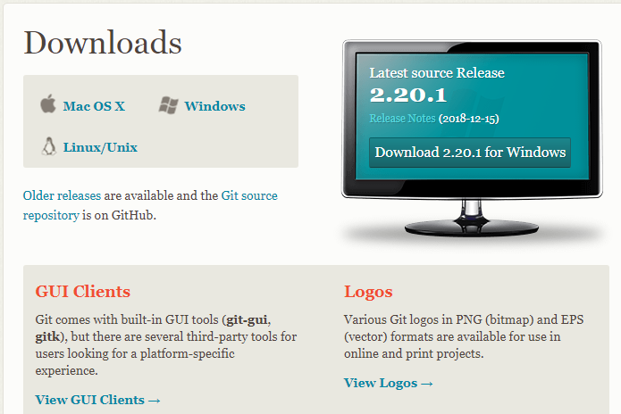

1. Install git using by clicking on exe which got downloaded (Git-2.20.1-64-bit.exe)
2. You will see the following screen, click Next  
   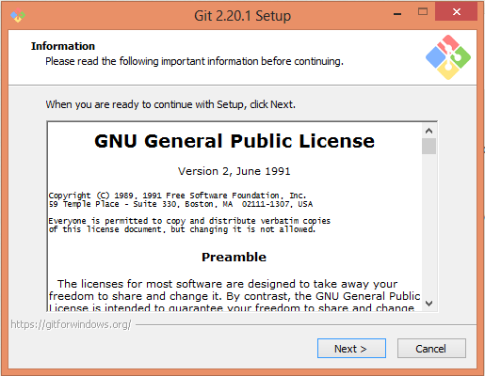
3. Select a folder or keep the default folder and click Next  
   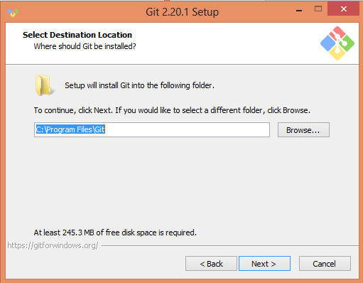
4. Options to select will come up , let the default select remain and just add the icon checkbox, which is the first option  
   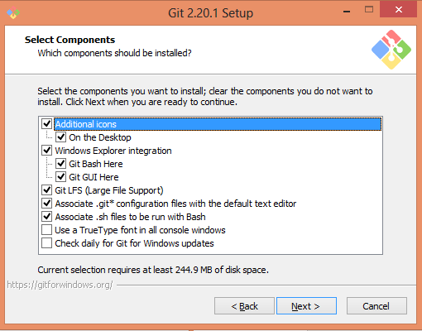
5. Start Menu window appears, just click Next   
   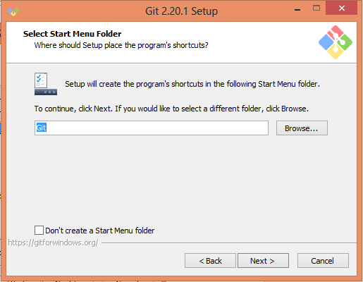
6. Next window to choose default editor will come up, choose Notepad++ and click Next.  
   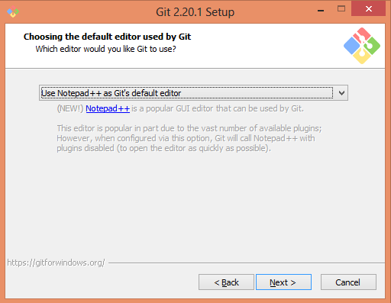
7. Adjusting Path environment window will come up. Let the default setting remain and click on Next  
   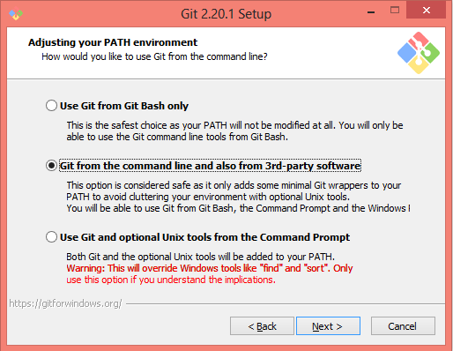
8. HTTPS transport backend window will appear, let the default setting and click on Next  
   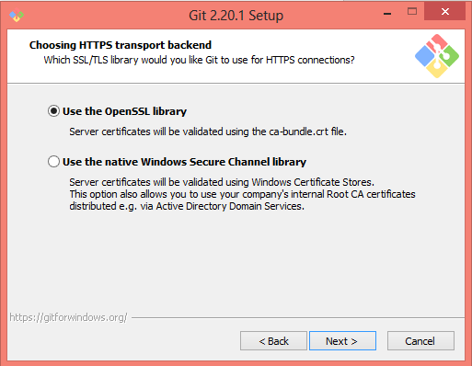
9. Configuring line ending conversions, let the default setting and click Next  
   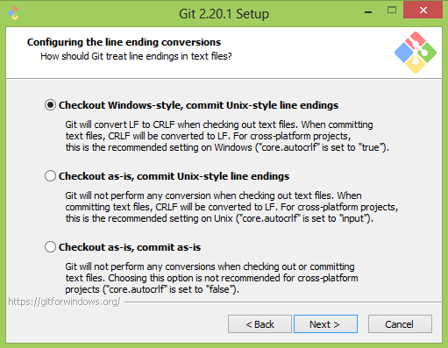
10. On Terminal Emulator window, keep the default setting and click on Next   
    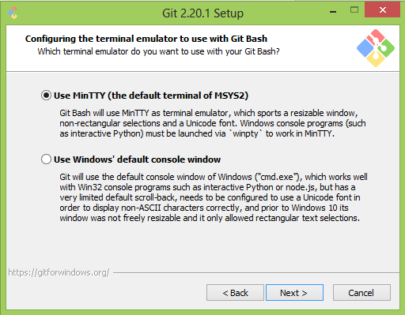
11. Configuring extra option window, keep the default and click Install  
    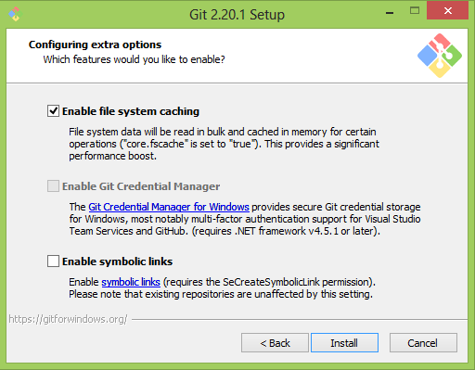
12. After installation following screen appears, click on Finish  
    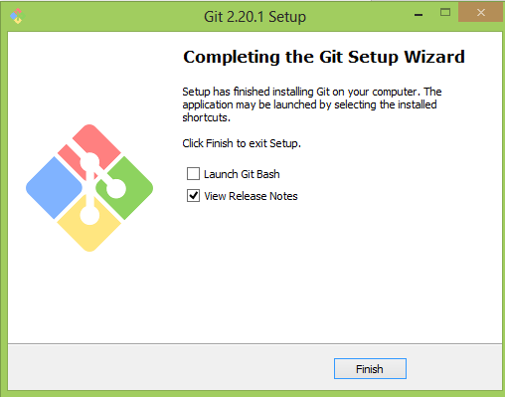
13. Now from desktop, search for Gitbash window icon and click on it,   
    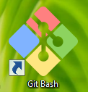
14. you should see the following screen  
    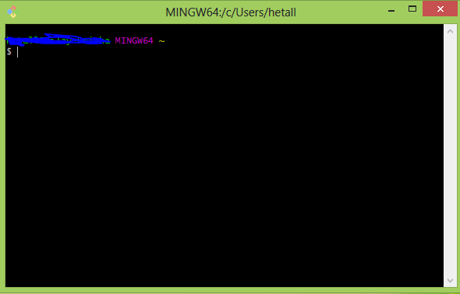
15. This completes the setup.